# The Blue heron

The Great Blue Heron is the most common and largest heron in North America. It is classified as a Species of Greatest Conservations Need by the Wyoming Game and Fish Department.

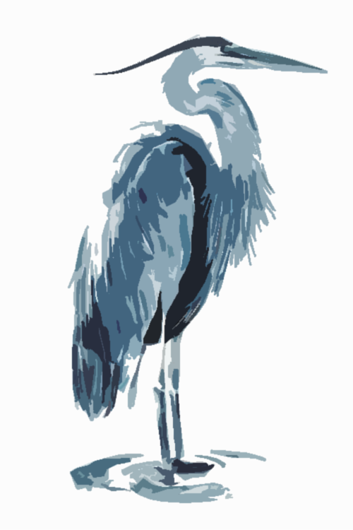

They are distinguished by their long bills, blue cap and wing feathers, “S” shaped neck and large wingspan – up to 79 inches in length!

Great Blue Herons are typically a summer breeding-only resident of Wyoming, but they can be spotted year-round.

During breeding season, colonies are often found near forest-bound lakes and ponds, as well as along the Snake River

Their diet consists mostly of fish, amphibians, insects, and even small mammals.

# Our Sustainable Partners

Durham Ranch, Gillette, WY

Lombardi Brothers, Denver, CO

Riverence, Buhl, ID

Great Lakes Cheese, Fillmore, UT

Slide Ridge Honey, Cache Valley, UT

Eagle Eye Farms, Idaho Falls, ID

Mountain View Farms, Fillmore, UT

Beehive Cheese, Ogden, UT

Glenview Farms, Kilbride, Canada

Grains of Montana, Billings, MT

****Appetite for Life: Healthy & Sustainable Cuisine

GF: *Gluten Free Ingredients Used* V: *Vegetarian* VG: *Vegan* DF: *Dairy Free*

*\*Consuming raw or undercooked meat may increase your risk of foodborne illness.*

*All menu items prepared in a facility that contains wheat, soy, dairy, tree nuts and ground nuts.*

*Please discuss any allergies or dietary restrictions with your server*

*Parties of 8 or more are subject to a 20% automatic gratuity.*

Brews

***DRAFT 16OZ / 22OZ***

**Snake River Brewing - Jackson, Wyoming** (8/10)

Earned It Hazy IPA 6%

Jenny Lake Lager 4.8%

Hike It Out Hefeweizen 5.4%

**Grand Teton Brewing - Victor, Idaho** (8/10)

Skillet Glacier Golden Ale 4.7%

Teton Amber Ale 4.7%

**Modelo Especial** (8/10)

**Stella Artois** (8/10)

**Michelob Ultra** (6/8)

***CanS***

**12oz Snake River Brewing Jackson, WY** (8)

Pako’s IPA 6.8%

Zonker Stout 6%

Pale Ale 5.2%

**16oz Roadhouse Brewing Jackson, WY** (10)

Wilson Mountain Style IPA 7.5%

Family Vacation Golden Ale 4.9%

**12oz Grand Teton Brewing Victor, ID** (8)

Parks Citra IPA 5.5%

Huckleberry Madness

Wheat Ale 4.7%

**12oz Highpoint Cider Victor, ID** (9)

Transplant 6%

Prairie Punch 6%

***NA BREWS***

**12oz Athletic Brewing** (8)

Run Wild IPA

Athletica Mexican Lager

**12oz Heineken Zero** (8)

Signature cocktails

**Jackson Lake Hard Lemonade** (14)

44 North Huckleberry Vodka and house-made lemonade with a splash of soda

Purchase a Jackson Lake Lodge pint glass for $10 and receive $2 off on your cocktail

**Teton Mule** (15)

44 North Huckleberry Vodka, ginger beer, and lime juice

Purchase a Jackson Lake Lodge copper mug for $20 and receive $2 off on your cocktail

**Mountain Mojito** (16)

Bacardi Rum muddled with lime, mint, and house-made huckleberry syrup with a splash of soda

**Three Nine Nine** (19)

Our signature Huckleberry margarita made with lime juice and agave served on the rocks with salt rim

**Blue Heron Bloody Mary** (15)

House-made bloody Mary with a hearty garnish and a Tajin rim

Purchase a Jackson Lake Lodge pint glass for $10 and receive $2 off on your cocktail

**Absaroka Negroni** (18)

Jackson Hole Stillworks Absaroka Barrel Aged Gin, Dolin Vermouth, Campari

**Colter’s Old Fashioned** (18)

Colter’s Run Bourbon and bitters come together in this Old Fashioned that John Colter himself would have walked days for

**The Wildfire** (17)

Montelobos Mezcal, 1800 Reposado, honey, lime juice, dash of bitters

**Peak Heat** (16)

House-infused jalapeno Hornitos tequila with lime juice and agave served on the rocks with Tajin rim

**Lupine Meadows** (17)

House-infused sage Great Grey Gin, honey, lemon juice, egg whites, lavender bitters

**Huckleberry Spritzer** (15)

House-made Huckleberry syrup, Maitea Cava

NA Cocktails

**Jackson Lake Lemonade NA** (12)

House-made huckleberry syrup and fresh lemonade

**Honey Bee** (14)

Mahala NA Botanical, lemon, lavender-honey syrup, and elderflower soda

**Lunch Tree Refresher** (12)

Grapefruit and lime juice, simple syrup, mint and sparkling cucumber water

Corks

***Sparkling***

**Maitea Cava Brut** (13/49)

Spain

**Mumm Prestige** Napa (17/80)

***White***

**Edna Valley** (13/51)

**Chardonnay** California

**Whitehaven** (17/66)

**Sauvignon Blanc** New Zealand

**Acrobat Pinot Gris** (14/55)

Oregon

**Lagar de Indra** (13/49)

**Albarino** Spain

**Vidigal Vinho Verde** (11/42)

Portugal

**Jackson Hole Winery** (21/82)

**Chardonnay** Wyoming

*A Corkage fee of $20 will be applied to bottles brought to the restaurant.*

*Parties of 8 or more are subject to a 20% automatic gratuity.*

***Rosé***

**Larchago Rosado** (12/45)

Spain

***Red***

**Acrobat Pinot Noir** (17/67)

Oregon

**Decoy Cabernet** (18/72)

**Sauvignon** Sonoma

**Izarbe Reserva**  (18/70)

**Tempranillo** Spain

**Edna Valley** (14/55)

**Cabernet Sauvignon**

California

**El Libre Malbec** (11/42)

Argentina

**MacMurray** (22/87)

**Pinot Noir** California

LiquoR

**(L) – Local**

**(R) – Regional**

**vodka**

Skyy 8

Grand Teton **(L)**  9

44 North Huckleberry **(R)** 10

Tito’s 10

Absolut 9

Jackson Hole Stillworks **(L)** 11

Belvedere 13

Grey Goose 14

Ketel One 11

**Gin**

Beefeater 9

Tanqueray 10

Tanqueray Ten 13

Aviation 12

Hendrick’s 13

Bombay Dry 9

Bombay Sapphire 10

Absaroka **(L)** 14

Great Grey **(L)** 11

The Botanist 13

**Tequila/Mezcal**

José Cuervo 9

1800 Silver 11

1800 Reposado 11

Tres Generaciones Anejo 15

Patrón Silver 14

Casamigos Blanco 14

Hornitos 11

Don Julio 1942 45

Espolón Blanco 13

Herradura Reposado 16

Del Maguey Vida Mezcal 15

Montelobos Mezcal 13

Casamigos Mezcal 16

**Rum**

Bacardi Superior /Gold 8

Captain Morgan 9

Mount Gay Eclipse Gold 10

Pyrat XO 12

Ron Zacapa Gold 15

Malibu Coconut 9

**Bourbon/whisky**

Jim Beam 9

Jack Daniel’s 10

Angel’s Envy 14

Maker’s Mark 12

Colter’s Run **(L)** 13

High West bourbon **(R)** 13

Bulleit Bourbon 12

Basil Hayden’s 14

Jameson Irish 11

Woodford Reserve 13

Widow Jane 22

Wyoming Whiskey **(L)** 13

Mountaineer **(L)**  13

Crown Royal RSV 14

Cowboy Country Distilling **(L)** 15

Bulleit 95 Rye 12

High West Double Rye **(R)** 13

Whistle Pig (Rye) 23

**scotch**

Dewar’s White Label 9

Chivas Regal 13

Cutty Sark 8

Johnnie Walker Red 10

Johnnie Walker Black 14

Macallan Sherry 12-Year 26

Monkey Shoulder 11

Dalwhinnie 15-Year 21

Talisker 10-Year 22

Laphroaig 10-Year Malt 18

Balvenie 12-Year 19

Glenlivet 12-Year 16

Glenfiddich 12-Year 16

Soups and salads

|  |
| --- |
| **Tomato Basil Soup - GF, V** (12) |
| **House Salad - GF, V** (13)  Spring Mix, Tomato, Cucumber, Carrot, Onion, Shaved Parmesan, Champagne Vinaigrette |
| **Burrata and Marinated Heirloom Tomato Salad - GF, V** (17)  Fresh Basil, Cracked Black Pepper, Aged Balsamic Reduction |
| **Watermelon-Feta Salad - GF, V** (15)  Arugula, Diced Watermelon, Crumbled Feta, Spiced Pistachio, Mint-White Balsamic Vinaigrette |

Small plates

|  |
| --- |
| **Marinated Olives and Mozzarella - GF, V** (9) |
| **Hummus Plate - VG** (15)  Kalamata, Seasonal Fresh Vegetables, Lavash |
| **Caramelized Onion Dip - GF, V** (13)  House Potato Chips |
| Chicken Chile Colorado Nachos (21)  House made Tortilla Chips, Green Chile Queso, Micro Cilantro  Pickled Fresno Peppers, Avocado Crema  *Substitute Steak Barbacoa +2* |
| **Steak Barbacoa Tostada (GF)** (19)  Queso Fresco, Refried Black Beans, Micro Cilantro, Avocado Crema |
|  |

Dessert

|  |  |  |
| --- | --- | --- |
| |  | | --- | | **New York Cheesecake** (11) Rotating Flavors | | **Boozy Sorbets** (11) Rotating Flavors  Appetite for Life: Healthy & Sustainable Cuisine  GF: *Gluten Free Ingredients Used* V: *Vegetarian* VG: *Vegan* DF: *Dairy Free*  *\*Consuming raw or undercooked meat may increase your risk of foodborne illness.*  *All menu items prepared in a facility that contains wheat, soy, dairy, tree nuts and ground nuts.*  *Please discuss any allergies or dietary restrictions with your server*  *Parties of 8 or more are subject to a 20% automatic gratuity.* | |

