The Blue heron
The Great Blue Heron is the most common and largest heron in North America. It is classified as a Species of Greatest Conservations Need by the Wyoming Game and Fish Department.
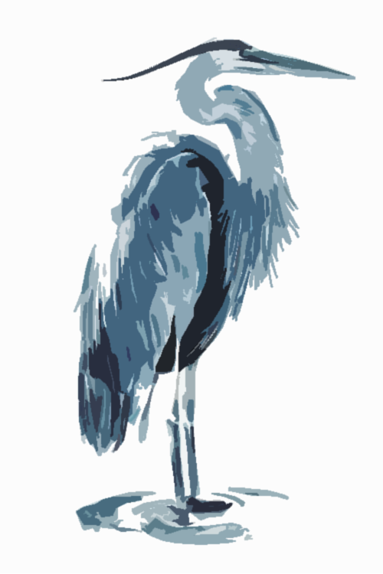
They are distinguished by their long bills, blue cap and wing feathers, “S” shaped neck and large wingspan – up to 79 inches in length!

Great Blue Herons are typically a summer breeding-only resident of Wyoming, but they can be spotted year-round.

During breeding season, colonies are often found near forest-bound lakes and ponds, as well as along the Snake River

Their diet consists mostly of fish, amphibians, insects, and even small mammals.

Our Partners
Durham Ranch, Gillette, WY
Sparboe Farms, Hudson, CO
Clear Springs Foods, Buhl, ID
Eagle Eye Farms, Idaho Falls, ID
Mountain View Farms, Fillmore UT
Slide Ridge Honey, Cache Valley, UT
Grains of Montana, Billings, MT
Grain Craft, Blackfoot, ID
West Point Dairy, Hyrum, UT
Dairy Gold Farms, Boise, ID
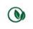Appetite for Life: Healthy & Sustainable Cuisine
GF: Gluten Free Ingredients Used V: Vegetarian VG: Vegan DF: Dairy Free
*Consuming raw or undercooked meat may increase your risk of foodborne illness.
All menu items prepared in a facility that contains wheat, soy, dairy, tree nuts and ground nuts.

Brews
DRAFT 16OZ / 22OZ

Skillet Glacier Golden Ale (7.50/9.00)
Grand Teton Brewing, Victor, ID
Teton Amber Ale (7.50/9.00)
Grand Teton Brewing, Victor, ID
Earned It Hazy IPA (7.50/9.00)
Snake River Brewing, Jackson, WY
Cross Czech Pilsner (7.50/9.00)
Snake River Brewing, Jackson, WY
See You In Helles (7.50/9.00)
Snake River Brewing, Jackson, WY
Jenny Lake Lager (7.50/9.00)
Snake River Brewing, Jackson, WY
Stella Artois (7.00/8.50)
Anheuser Busch
Bud Light (5.00/6.50)
Anheuser Busch

CRAFT CANS
Grand Teton Juicy IPA (7.50)
Snake River Brewing (7.50)
Zonker Stout, Pale Ale, Pako’s IPA, Jenny Lake Lager
Roadhouse Brewing (8.00)
Wilson Mountain Style IPA, Family Vacation Golden Ale
Ascent Kombucha (10.00)
Ginger & Juice (NA)
Huckleberry (NA)

DOMESTIC CANS
Pacifico (7.00)
Michelob Ultra (6.00)
Bud Light (5.00)
Budweiser (5.00)
White Claw Mango (7.00)
White Claw Black Cherry (7.00)
Bud Zero (NA) (5.00)

SIGnature cocktails
Jackson Lake Lemonade (13.00)
44 North Huckleberry Vodka and house-made lemonade with a splash of soda
Have your lemonade served in our souvenir Jackson Lake Lodge pint glass for $8 and receive $2 off on your cocktail.
Huckleberry Mule (14.00)
44 North Huckleberry Vodka, ginger beer and lime juice

Have your Mule served in our souvenir Jackson Lake Lodge copper mug for $20 and receive $2 off on your cocktail.
Mountain Mojito (16.00)
Bacardi Rum muddled with lime, mint, and huckleberry served over ice
with a splash of soda
399 Huckleberry Margarita (17.50)
Our signature margarita made with fresh squeezed lime juice and agave served on the rocks with or without salt

Blue Heron Bloody Mary (14.00)
House-made bloody mary with a hearty garnish

Colter’s Old Fashioned (16.00)
Colter’s Run Bourbon and bitters come together in this Old Fashioned that John Colter himself would have walked days for.

The Caballero (17.00)
House infused jalapeno tequila with fresh squeezed lime juice and agave served on the rocks with salt

String Lake Spritzer (14.00)
House infused cucumber vodka, St. Germain Liqueur, fresh squeezed lemon juice topped off with La Marca Prosecco

Absaroka Negroni (17.00)
Jackson Hole Stillworks Absaroka Gin, Dolin Vermouth, Campari

Lupine Meadows (16.00)
Sage infused Great Grey Gin, lemon juice, dashes of bitters, topped with soda

Jackson Hole Stillworks Vesper (16.00)
Great Grey Gin, Stillworks Vodka, Lillet

Paintbrush Canyon Spritzer (13.00)
Aperol, La Marca Prosecco

Corks
Rose & SParking

La Marca Prosecco (12/56)
Tre Venezie, Italy
Mumm Cuvee Napa Prestige (14/75)
Napa Valley, CA
The Palm Rose (13/50)
Languedoc, France

WHITE

Edna Valley, Paragon Chardonnay (12/47)
Central Coast, CA
Whitehaven Marlborough Sauvignon Blanc (16/61)
Marlborough, New Zealand
Acrobat Pinot Gris (13/51)
Willamette Valley, Oregon
Vidigal Vihno Verde (10/35)
Leiria, Portugal

RED

Acrobat Pinot Noir (17/67)
Willamette Valley, Oregon
Las Rocas Garnacha (11/44)
Calatayud, Spain
Don Miguel Gascon Malbec (13/50)
Mendoza, Argentina
Edna Valley Cabernet Sauvignon (14/53)
Central Coast, CA

Liquor

vodka
Skyy
Grand Teton (L)
Grand Teton Huckleberry (L)
44 North Huckleberry (R)
High Water (L)
Tito’s
Stolichnaya
Absolut
Absolut Citron
Absolut Vanilla
Absolut Mandarin
Belvedere
Grey Goose
Ketel One

Gin
Beefeater
Tanqueray Ten
Aviation
Hendrick’s
Bombay Dry
Bombay Sapphire
Absaroka (L)
Great Grey (L)
The Botanist

Rum
Bacardi Light
Bacardi Gold
Bacardi 151
Myer’s Dark
Captain Morgan
Mount Gay Eclipse Gold
Pyrat XO Gold
Ron Zacapa Gold
Malibu Coconut
Captain Morgan Private

(L) - Local

(R) - Regional

Bourbon
Jim Beam
Maker’s Mark
Colter’s Run (L)
High West American Prairie (R)
Bulleit Bourbon
J&B Rare

Tequila
Jose Cuervo Gold
1800 Silver
1800 Reposado
Tres Generaciones Anejo
Patron Silver
Casamigos Blanco
Del Maguey Vida
Sauza

Whiskey
Jack Daniel’s
Jameson Irish
Wyoming Whiskey (L)
Crown Royal
Crown Royal Reserve
Bulleit 95 Rye
Evan Williams
High West
Jim Bean Black
Seagram’s 7
Whistle Pig (Rye)

scotch
Dewar’s
Dewar’s White Label
Chivas Regal
Cutty Sark
Johnnie Walker Red
Johnnie Walker Black
Macallan 12-year
Monkey Shoulder
Dalwhinnie 15-Year
Talisker 10-Year
Laphroaig 10-Year Malt
Balvenie 12-Year

SOUPS AND SALADS
Tomato Bisque (GF, Veg) 11
Bourbon Sweet Corn-Smoked Trout Chowder (GF) 13
House Salad (GF, Veg) 12
Spring Mix, Tomato, Cucumber, Carrot, Marinated Onion, Shaved Parmesan, Champaigne Vinaigrette
Roasted Beet Salad (GF, Veg) 14
Spring Mix, Goat Cheese, Red Onion, Granny Smith Apple, Candied Walnuts, Huckleberry-Sage Vinaigrette
Watermelon-Feta Salad (GF, Veg) 14
Arugula, Diced Watermelon, Crumbled Feta, Cucumber, Spiced Pepitas, Mint-White Balsamic Vinaigrette

SMALL PLATES
Chilled Edamame (GF, V) 11
Sesame Oil, Black Sesame Seeds
Pita Chips and Sundried Tomato Hummus (Veg) 13
Feta, Kalamata, Marinated Onion, Tzatziki
Duck Confit Nachos (GF) 22
House Tortilla Chips, Green Chili Queso Blanco, Diced Green Onion, Cilantro, Avocado Crema
Mini Tostadas (GF) 14
Green Chili Pulled Pork, Cotija, Cilantro Chimichurri
French Onion Dip 13
Caramelized Onion and Gruyere Cheese Dip, House Lavash
Orange-Cranberry Chicken Salad Wrap 19
Lettuce, Tomato, Marinated Onions, Flour Tortilla
GRILL MENU
All Sandwiches come with a choice of potato chips or tossed greens

Grilled Cheese (Veg) 15
Fontina, Gruyere, Blistered Grape Tomatoes, Pesto, Ciabatta
Marinated Oyster Mushroom Banh Mi (Veg) 16
Cucumber, Pickled Daikon and Carrots, Sriracha Aioli, Cilantro, French Baguette
Jenny Lake Lager Bratwurst (DF) 17
Beer Braised Bratwurst, Sauerkraut, Honey Mustard, Hoagie Roll
Cubano 18
Mojo Pork, Smoked Ham, Swiss Cheese, Dijon Aioli, Pickle, Ciabatta
Beef n’ Cheddar 23
Shaved Tri-Tip, White Cheddar Cheese Sauce, Horseradish Aioli, Grains of Montana Brioche
Blue Heron Burger 18
1/3-lb Beef Patty, Bourbon Bacon-Onion Marmalade, White Cheddar, Dijon Aioli, Lettuce, Tomato, Onion, Pickle, Brioche
Balsamic Blue Burger 19
1/3-lb Beef Patty, Balsamic Red Onions, Blue Cheese, Lettuce, Tomato, Pickle, Brioche
Hawaiian Burger 20
1/3-lb Beef Patty, Grilled Pineapple, Soy-Mirin Bacon, Teriyaki Sauce, Lettuce, Tomato, Onion, Brioche

